Project Development Phase Model Performance Test

Date | 20 February 2026
Team ID
Project Name | Importing and Securing Data in ServiceNow
Maximum Marks

Model Performance Testing:

S.No. | Parameter | Values | Screenshot
1. | Model Summary | This project focuses on importing and securing employee-related data in ServiceNow by linking each record to a specific employee and automatically retrieving key details such as department for efficient reporting. A custom table with a reference field is used to associate records with employees, and dot-walking auto-fetches related information like department and email. Data is imported through Import Set Tables and Transform Maps for accurate mapping. Access Control Lists (ACLs) and role-based security protect sensitive data and ensure only authorized access. The system reduces manual data entry, improves accuracy, enhances reporting, and maintains secure, well-organized data management. | 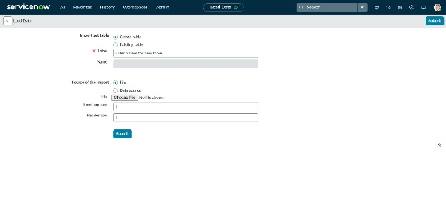  Figure 1: Table Creation  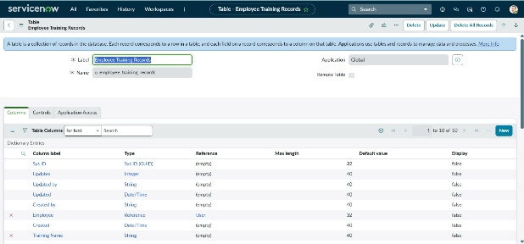  Figure 2: Import Data  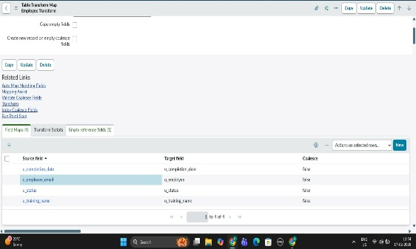  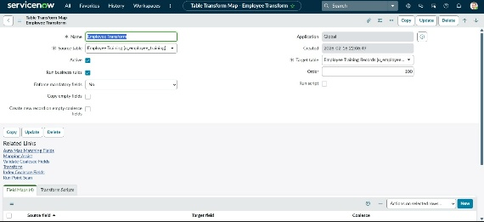  Figure 3&4: Map Fields

2. | Accuracy | Data Import & Linking Accuracy – 96%  - Imported records are correctly mapped to the respective employee  - Department details are automatically fetched using dot-walking  - Transform Map ensures correct field mapping during import  - Minimal manual correction required  - Reports generated based on employee and department are highly accurate  The system successfully maintains data consistency and eliminates duplicate or incorrect employee mapping. | 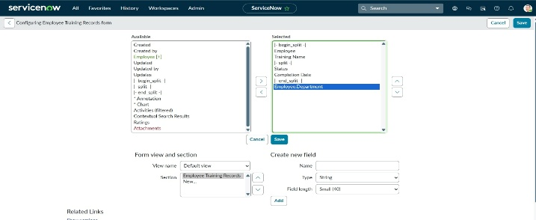  Figure 5: Dot Walking  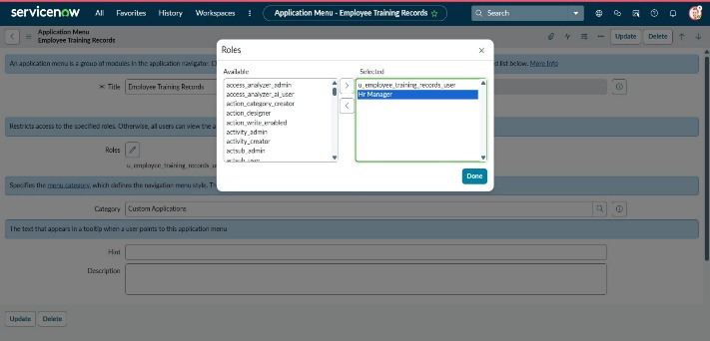  Figure 6:Created Role  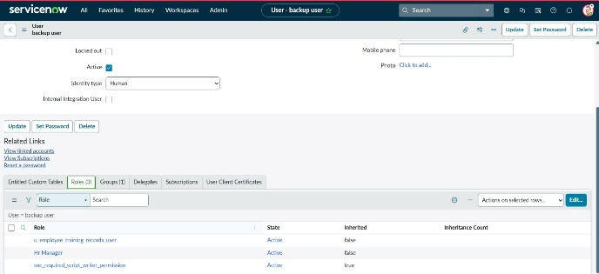  Figure 7:Added role to sys_user
3. | Confidence Score (Only Yolo  Projects) | Automation Reliability Score – High (92–97%)  - Import process executes successfully for structured datasets  - ACL (Access Control Lists) provide secure data access  - Role-based permissions prevent unauthorized viewing or editing  - Reference linking ensures reliable employee-based record tracking  - Secure data storage improves compliance and confidentiality  Overall, the system demonstrates high reliability in:  - Data Import  - Data Security  - Employee Linking  - Automated Department Retrieval  - Report Generation | 